System Requirements Statement (SRS) –

FarmGuide

1. Introduction 3

2. Functional Requirements 4

2.1 Farmer Module 5

2.2 Wholesaler Module 11

2.3 admin Module 17

2.4 UseCaseDiagram...........................................................................................................................22

THIS DOCUMENT CONTAINS 24 NUMBERED PAGES

# Introduction

This document explains the system requirements and scope for developing FarmGuide system, a web-based application aimed at providing a comprehensive guide and platform for farmers to improve their farming practices, and connect with wholesalers. FarmGuide is designed to be a valuable resource for farmers, particularly those Farmers who want to improve their Farming technique.

FarmGuide system is divided in three main parts, farmer part, wholesaler part, admin part.

# Functional Requirements

The Account part of FarmGuide System has three modules which are divided following processes described as below.

|  |  |  |
| --- | --- | --- |
| Module | Requirement ID | Requirement Description |
| Farmer Module | 1 | Login Process and subscription |
|  | 2 | Order and Transaction History |
|  | 3 | Forgot Password Process |
|  | 4 | Change Password Process |
|  | 5 | Delete Account Process |
|  | 6 | Search Product |
|  | 7 | Publish Product for Sale |
|  | 8 | Update Product Information |
|  | 9 | Delete Product |
|  |  |  |
| Wholesaler Module | 10 | Forgot Password Process |
|  | 11 | Order and Transaction History |
|  | 12 | Change Password Process |
|  | 13 | Delete Account Process |
|  | 14 | Search and Buy Product |
|  | 15 | Payment Process |
|  |  |  |
| Admin Module | 16 | Login Process |
|  | 17 | Forgot Password Process |
|  | 18 | Change Password Process |
|  | 19 | Manage Farmer Accounts |
|  | 20 | Manage Wholesaler Account |
|  |  |  |

## Farmer Module

* Farmer is the user of system who wants to sell the product.
* He is able to browse existing Market price.
* He will be able to get details of crops.
* FAQ section will help farmers to upload questions and others can help
* Farmer will get notified about who bought his crops and maintain history

### Registration, Login Process and Subscription

* Farmers must create an account before using the system.

So, FarmGuide System should provide the function which makes farmer create new account.

* When farmer creates new account, the function demands two information described as below.

1. Login information
2. Contact Details

* The Login information

The Login information consists of some items described as below.

1. Phone Number
2. Password
3. First Name
4. Last Name
5. E-mail address
6. User Type
   * All items are compulsory demanded.
   * Phone Number

* The Phone number should be unique. If the Phone Number correspond with non-digit character, the Phone number should not be registered as an account.
  + Password
* The Password has constraints which makes the Password consists of more than or equal 8 and less than or equal 16 characters including characters described as below.

1. Numeric figure (at least one)
2. Capital alphabet (A-Z) (at least one)
3. Small alphabet (a-z) (at least one)
4. Special character (#, $, %, &, etc.) (at least one)

* The Password is masked by dummy characters. The re-entering Password is demanded.
* The Password must be encrypted in FarmGuide System.
  + User Type

The User Type falls into two categories described as below.

1. Farmer
2. Wholesaler

* In Account Creation Process, the user can select either he is Farmer / Wholesaler.
* Contact Details
* The Contact Detail consists of some items described as below.

1. Permanent Address
2. Contact Number
   * All items are compulsory demanded.
   * Permanent Address

* Permanent Address should be filled.
* But only the state should be selected from options.
* The Security Question information

The Security Question information is needed when farmer forgot their Password. This information consists of two items described as below.

1. Selected Question
2. Answer
   * All items are compulsory demanded.
   * Some questions which are difficult to answer for anyone else are prepared in advance.

E.g. what do you like most?

* + A question should be selected from options by the farmer, and the Answer is registered by the farmer.
* Login information should be entered on one screen, and then farmer information and Security Question information should be entered on another screen.

### Login Process

* FarmGuide System always compels user authentication before using itself except when a new account is successfully created.
* The user authentication demands Phone Number and Password. The Phone Number and the Password should be authenticated.
  + The Phone Number and the Password should be existing and correct.
* The farmer account should be active till the subscription lasts.
* The “Farmer Home” provides some items described as below.

1. A trigger to logout
2. A trigger to Account
3. A trigger to Search Product
4. A trigger to Publish, Update and Delete Product
5. A trigger to Crop Information
6. A trigger to FAQ Section
   * 1. **Order and Transaction Details**

* The placed orders list and payment information of that orders are provided in this section.
* This feature is accessible when farmer successfully login in his account.
* This feature is available in account section.
* The farmer will be able to see his placed orders and the payment information of that respective order in that order.
* The Orders are displayed according to history in descending order(newest to oldest).

### Forgot Password Process

* When system user lost their Password, the recovery method should be provided by FarmGuide system.

The recovery method is described as below.

* + First, system user enters their Phone Number for FarmGuide System.
  + Next, FarmGuide System demands the Answer which has been registered since when the Account was created.
  + Only when the Answer is correct, farmer get the new password by E-mail which also has been registered since when the Account was created.
  + The farmer can enter the new Password.
* The new password should be according to the password constraints.
* As a consequence, The Farmer could get the farmer authentication using the new password.
* If the Answer is not correct, then the correct Answer is demanded for user again.

### Change Password Process

* When farmer wants to change their Password, the measure should be provided by FarmGuide System.
* Therefore, FarmGuide System should provide the function which is available after getting the farmer authentication. This function is available in account section
* The function demands the current password and the new password.
  + The new password should consist of more than or equal 8 and less than or equal 16 characteristics including at least a numeric figure, a capital alphabet, a small alphabet, and a special character.
  + The current password and the new password are masked by using dummy characters.
  + The new password is demanded to enter twice to avoid a typing error.
* Only when the current password is correct, farmer could change their Password.
* When the current password is changed into new password, FarmGuide System compels user authentication again.

### Update Account Process

* FarmGuide System should provide the function which makes the account updated for farmer.
* The information farmer could update is described below.

1. Login information
2. User information
3. Security Question Information

* The Login information

The updatable items as described below.

1. First Name
2. Last Name
3. E-mail address
   * All items are compulsory demanded, but updating is optional.

* The User information

The updatable items as described below.

1. User Name
2. User Phone No
3. E-mail address
4. Permanent address
   * All items are compulsory demanded, but updating is optional.

* The Security Question information

The updatable items as described below.

1. Selected Question
2. Answer
   * All items are compulsory demanded, but updating is optional.

**2.1.6 Delete Account**

* In this function farmer will be able to delete his account.
* This feature is available in account section.
* While deleting account farmer need to provide his login credentials for confirmation about his account deletion.
* The deletion process will proceed only if login credentials like mobile number and password matches exactly.

### 2.1.7 Search product

* Farmers can search for products listed by other farmers based on the following criteria:

1. Product category
2. Price range

### Publish product for sale

Farmers can publish their products for sale by providing the following information:

1. Product category
2. Price
3. Product name
4. Quantity
5. Photos

### Before publishing, farmers can view the existing market prices for similar products to determine a competitive price.

### Update product information

* After publishing the product , farmers can only update following contents.

1. Product quantity
2. Product price.
3. Other product details, such as category and name, cannot be modified once published.

### Delete product information

• After Publishing if farmer wants to remove some products then he can delete the product.

### Browse existing product Price

• Farmer could see the information of existing products.

**2.1.13 FAQ Management**

- The system includes an FAQ (Frequently Asked Questions) section where farmers can post questions related to farming practices, crop management, and other relevant topics.

- Other farmers and agricultural experts can provide answers and solutions to these questions, fostering a collaborative knowledge-sharing environment.

#### Wholesaler Module

### Account Creation Process

* FarmGuide System compels to create the account before using it. So, FarmGuide System should provide the function which makes wholesaler creates new account.
* When wholesaler creates new account, the function demands four information described as below.

1. Login information

2.Contact Details

3.Security Question Information

4.Payment information.

* The Login information

The Login information consists of some items described as below.

5.Phone Number

6.Password

7.First Name

8.Last Name

9.E-mail address

10.User Type

* + All items are compulsory demanded.
  + Phone Number
* The Phone Number should be unique. If the Phone Number correspond with not case-sensitive to other which is previously registered, the Phone Number should not be registered as an account.
  + Password
* The Password has constrains which makes the Password consists of more than or equal 8 and less than or equal 16 characteristics including characters described as below.

1.Numeric figure (at least one)

2.Capital alphabet (A-Z)(at least one)

3.Small alphabet (a-z)(at least one)

4.Special character (#, $, %, &, etc.) (at least one)

* The Password is masked by dummy characters. The re-entering Password is demanded.
* The Password must be encrypted in FarmGuide System.
  + User Type

The User Type falls into three categories described as below.

1.Farmer

2.Wholesaler

3.Administrator

* In an Account Creation Process, the user can select Wholesaler.
* No one could select The Administrator, because Administrator is implemented to FarmGuide System in advance.
* Contact Details
* The Contact Detail consists of some items described as below.

1.Permanent Address

2.Contact Phone No

* + All items are compulsory demanded.
  + Permanent Address
* Permanent Address should be filled.
* But only the state should be selected from options.
* The Security Question information

The Security Question information is needed when Wholesaler lost their Password. This information consists of two items described as below.

1. Selected Question
2. Answer
   * All items are compulsory demanded.
   * Some questions which are difficult to answer for anyone else are prepared in advance.

E.g. which colour do you like most?

* + A question should be selected from options by the Wholesaler, and the Answer is registered by the Wholesaler.
* Login information should be entered on one screen, and then Wholesaler information and Security Question information should be entered on another screen.

### Login Process

* FarmGuide System always compels Wholesaler authentication before using itself except when a new account is successfully created.
* The user authentication demands Phone Number and Password. The Phone Number and the Password should be checked in three ways.
  + First, The Phone Number and the Password should be existed and correct.
* If The Phone Number and the Password are not equal to what the user has registered, the user authentication cannot be provided.
  + Second, the User Type linked to the Phone Number should be "user".
* When the User Type is " Wholesaler ", user can be placed on “Wholesaler Home”.
  + Finally, Phone Number should be available.
* The Administrator can decide whether the Phone Number is available or suspended – Refer to the SRS of the Admin part.
* If user is rejected, user authentication is not provided for Wholesaler.
* The Wholesaler account should alive for so long as the duration decided by Admin.
* Only when the three checks are successfully completed, Wholesaler can be placed on respected page.
* The “Wholesaler Home” provides the some items described as below.
  + - 1. A trigger to logout
      2. A trigger to Account

1. A trigger to Search Product
2. A trigger to Browse existing Market price(state wise)
3. A trigger to Buy products

### Forgot Password Process

* When Wholesaler lost their Password, the recovery method should be provided by FarmGuide system.

The recovery method is described as below.

* + First, Wholesaler enters their Phone Number for FarmGuide System.
  + Next, FarmGuide System demands the Answer which has been registered since when the Account was created.
  + Only when the Answer is correct, Wholesaler get the new password by E-mail which also has been registered since when the Account was created.
  + The new password is automatically generated by FarmGuide System.
* The new password should consist of more than or equal 8 and less than or equal 16 characteristics including at least a numeric figure, a capital alphabet, a small alphabet, and a special character.
* As a consequence, The Wholesaler could get the user authentication using the new password.
  + Then, the Wholesaler had better change the new password manually.
* If the Answer is not correct, otherwise, the correct Answer is demanded for Wholesaler again.
  + In that case, Of course, Wholesaler couldn’t get the new password.

### Change Password Process

* When Wholesaler wants to change their Password, the measure should be provided by FarmGuide System.
* Therefore FarmGuide System should provide the function which is available after getting the Wholesaler authentication.
* This option is available in account section.
* The function demands the current password and the new password.
  + Of course, the new password should consist of more than or equal 8 and less than or equal 16 characteristics including at least a numeric figure, a capital alphabet, a small alphabet, and a special character.
  + The current password and the new password are masked by using dummy characters.
  + The new password is demanded to enter twice to avoid a typing error.
* Only when the current password is correct, Wholesaler could change their Password.
* When the current password is changed into new password, FarmGuide System compels Wholesaler authentication again.

### Update Account Process

* FarmGuide System should provide the function which makes the account updated for Wholesaler.
* The information Wholesaler could update is described below.

1. Login information

2. User information

3. Security Question Information

* The Login information

The updatable items as described below.

1. First Name
2. Last Name
3. E-mail address
   * All items are compulsory demanded, but updating is optional.

* The User information

The updatable items as described below.

1. User Name
2. User Phone No
3. E-mail address
4. Permanent address
   * All items are compulsory demanded, but updating is optional.

* The Security Question information

The updatable items as described below.

1. Selected Question
2. Answer
   * All items are compulsory demanded, but updating is optional.

#### Search Product

• Search conditions are described as below.

1. Product category

2. Price range

• As the result of searching Requirements, Wholesaler could see the list of products which are available for sale.

1. Product name

2. Price

3. Quantity

4. Photos

#### Buy Product

• To buy the product followings are the condition

1. Product category

2. Price range

3. Product Quantity

4. Product Name

**2.2.9 Transaction Management**

* This function is available in account section.
* In this function the wholesaler is able to see his ordered details and he will be able to cancel his placed order also within given amount of time otherwise order would not be cancelled.

Browse existing product Price

• Wholesaler could see the information of existing product**s.**

#### Admin Module

**•** Administratorshould be responsible for following activities**:**

### Login Process

* FarmGuide System always compels user authentication before using itself except when a new account is successfully created.
* The user authentication demands Phone Number and Password. The Phone Number and the Password should be checked in three ways.
* The Phone Number and the Password should be existing and correct.
* When the User Type is "Admin", user can be placed on “Admin Home”.
* The admin account should alive for so long as the duration decided by Admin.
* The “Admin Home” provides items described as below.

1. A trigger to logout
2. A trigger to update Account
3. A trigger to Change Password
4. A trigger to Search Product
5. A trigger to Publish Product for sale
6. A trigger to Update Product Information
7. A trigger to Delete Product
8. A trigger to Browse existing Market price
9. A trigger to Transaction Management

### Forgot Password Process

* When Admin lost their Password, the recovery method should be provided by FarmGuide system.

The recovery method is described as below.

* + First, Admin enters their Phone Number for FarmGuide System.
  + He will enter the E-mail id since when the Account was created.
  + Only when the E-mail Id is correct, Admin get the new password by E-mail which also has been registered since when the Account was created.
* The new password should be according to the password constraints.
* As a consequence, The Admin could get the admin authentication using the new password.

### Change Password Process

* When Admin wants to change his Password, the measure should be provided by FarmGuide System.
* Therefore, FarmGuide System should provide the function which is available after getting the admin authentication.
* The function demands the current password and the new password.
* The new password should be according to the password constraints.
  + The current password and the new password are masked by using dummy characters.
  + The new password is demanded to enter twice to avoid a typing error.
* Only when the current password is correct, Admin could change his Password.
* When the current password is changed into new password, FarmGuide System compels user authentication again.

### Update Account Process

* FarmGuide System should provide the function which makes the account updated for Admin.
* The information Admin could update is described below.

1. Login information
2. User information
3. Security Question Information

* The Login information

The updatable items as described below.

1. First Name
2. Last Name
3. E-mail address
   * All items are compulsory demanded, but updating is optional.

* The User information

The updatable items as described below.

1. User Phone No
2. E-mail address
3. Permanent address
   * All items are compulsory demanded, but updating is optional.

* The Security Question information

The updatable items as described below.

1. Selected Question
2. Answer
   * All items are compulsory demanded, but updating is optional.

#### Transaction Management

* **View All Transactions**
  + Enable the admin to view the complete history of transactions conducted within the system.
  + Transactions include product purchases, payments, refunds, and cancellations.
* **Filter and Search Transactions**
  + Provide functionality to filter and search transactions based on various criteria, such as date, user type (farmer or wholesaler), transaction status, and product category.
* **Generate Transaction Reports**
  + Allow the admin to generate reports on transaction activities for analysis and record-keeping.
  + Reports can be exported in various formats (e.g., PDF, Excel) for offline review.

#### Record Generation

• Admin should able to see all the records from any users.

• Daily report of enrolment to admin.

#### Accounts Management

• Admin should able to manage all the accounts with following activities,

1. Enable accounts

2. Disable accounts

#### 2.4 Use Case Diagram

**Admin:**

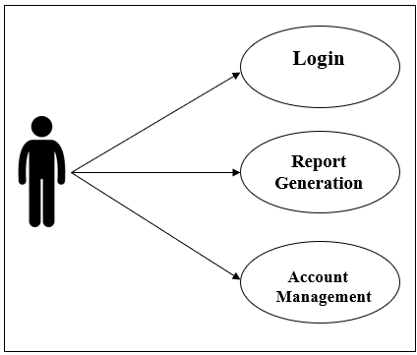

*Fig. Use case diagram for admin*

1. In Admin use case diagram Admin is the Actor.
2. Admin can handle following use cases:
3. Login
4. Report Generation
5. Controls accounts

**Farmer:**

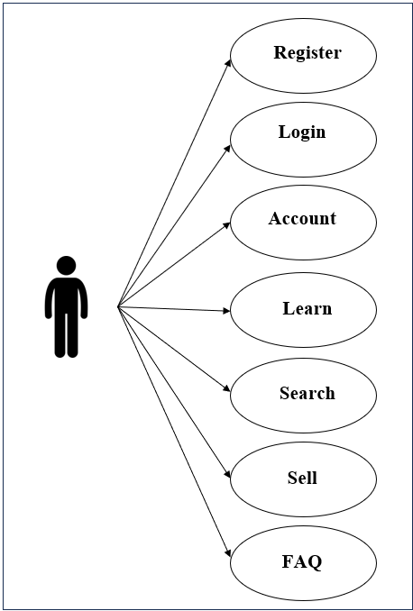



*Fig. Use case diagram for Farmer*

1. In Farmer use case diagram Farmer is the Actor.
2. Farmer can handle following use cases:
3. Register
4. Login
5. Search Product
6. Publish Product
7. Update Product
8. Delete Product
9. Browse Product Price

**Wholesaler:**

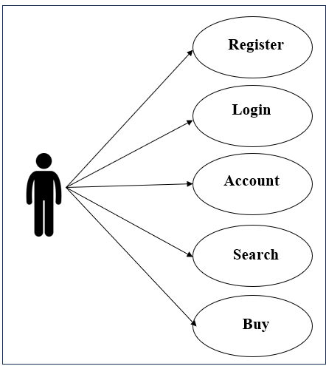

*Fig. Use case diagram for Wholesaler*

1. In Wholesaler use case diagram Wholesaler is the Actor**.**
2. Wholesaler can handle following use cases:
3. Register
4. Login
5. Search Product
6. Buy Product
7. Payback
8. Cancel Order
9. Browse Product Price